PROCEDURE TO INSTALL ECLIPSE IDE FOR WINDOWS

1. Install Cygwin
2. Install JRE and add path to environmental Variable
3. Install Eclipse IDE for C/C++ developer.
STEP-1 ( Install Cygwin )
- Open Cygwin website and download the software
- Double click on the file to install.
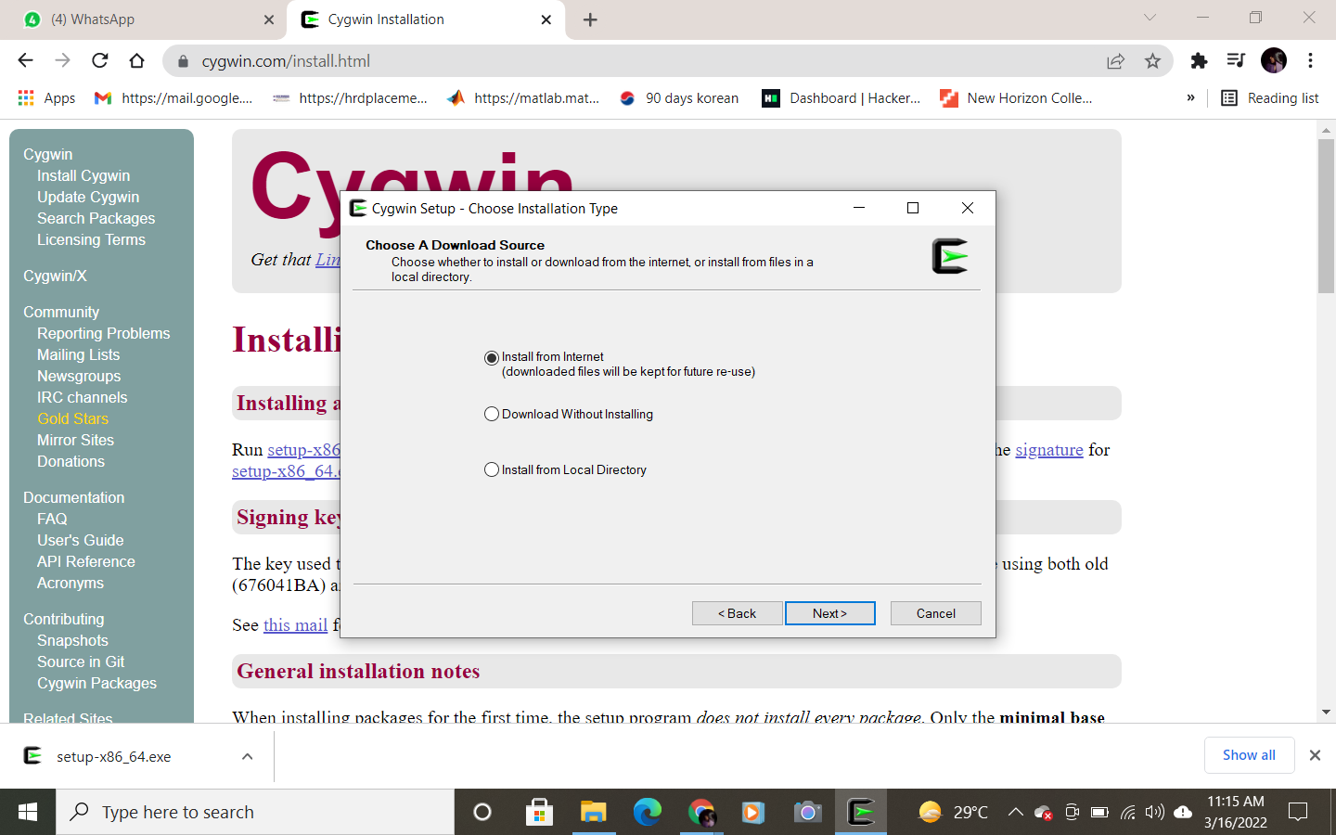
- Click on next
- Select the location
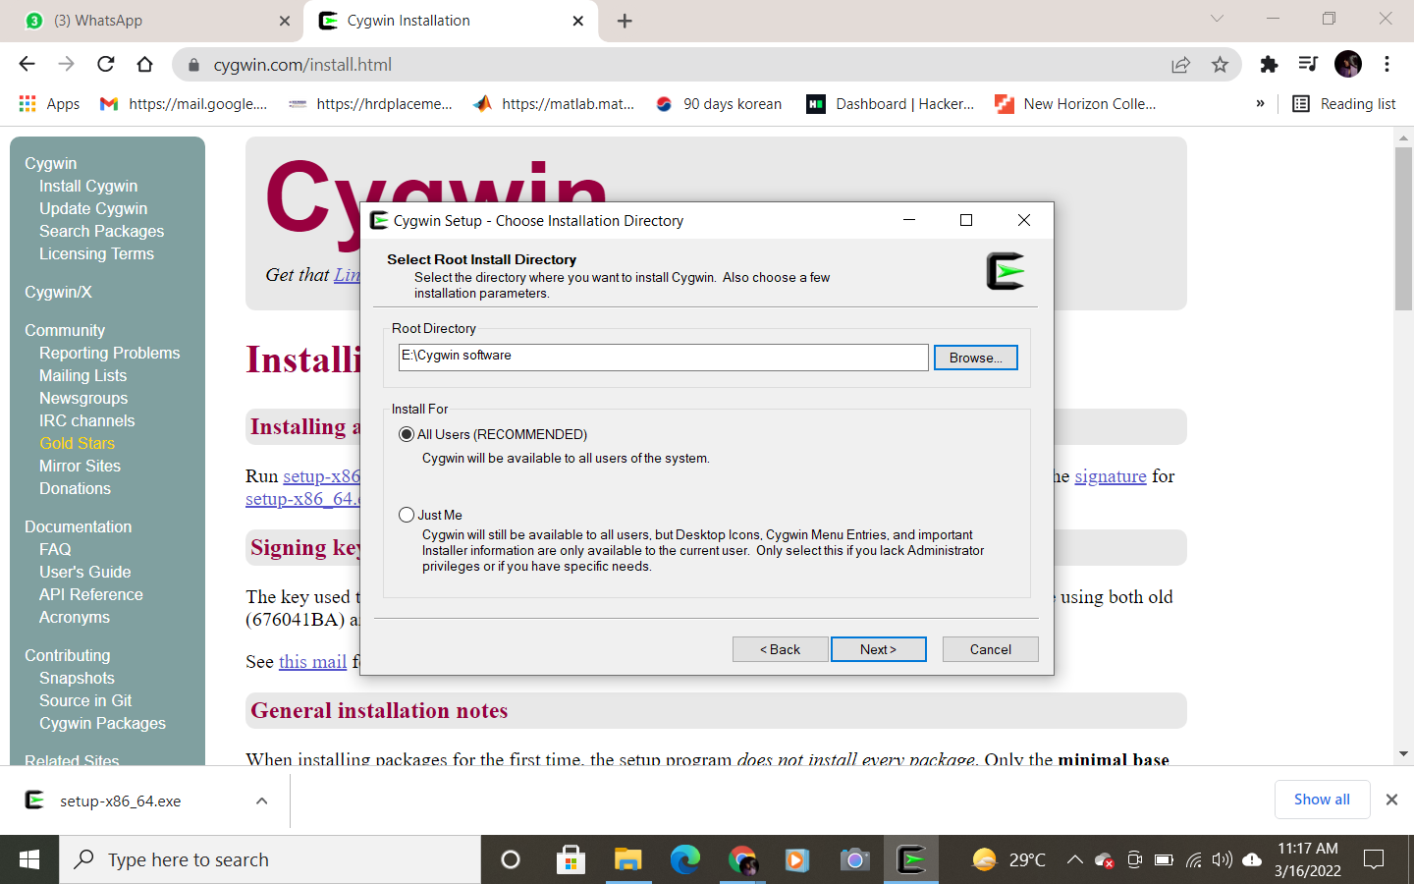

- Select a file.
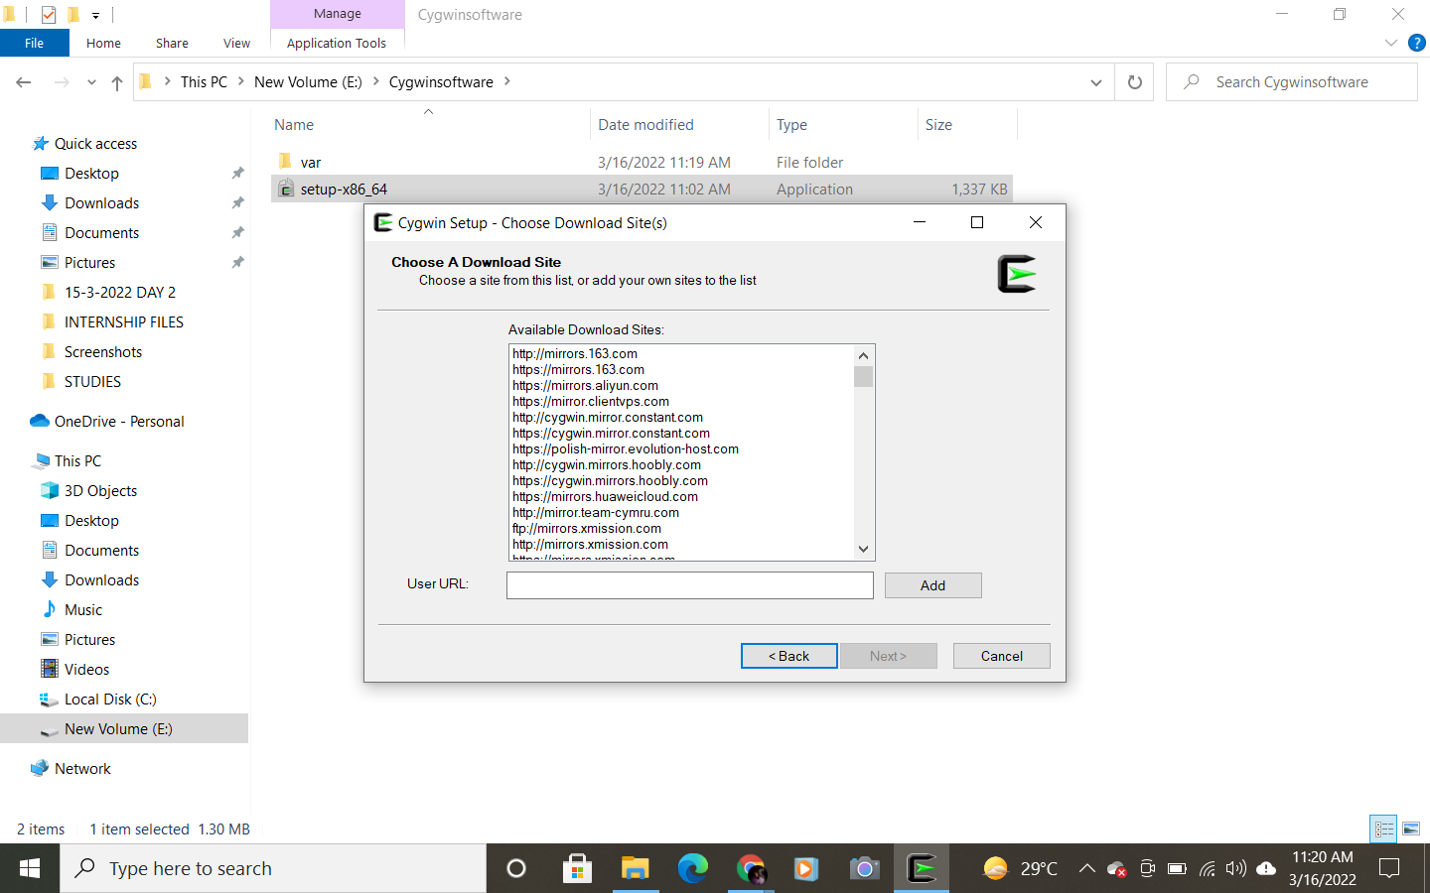

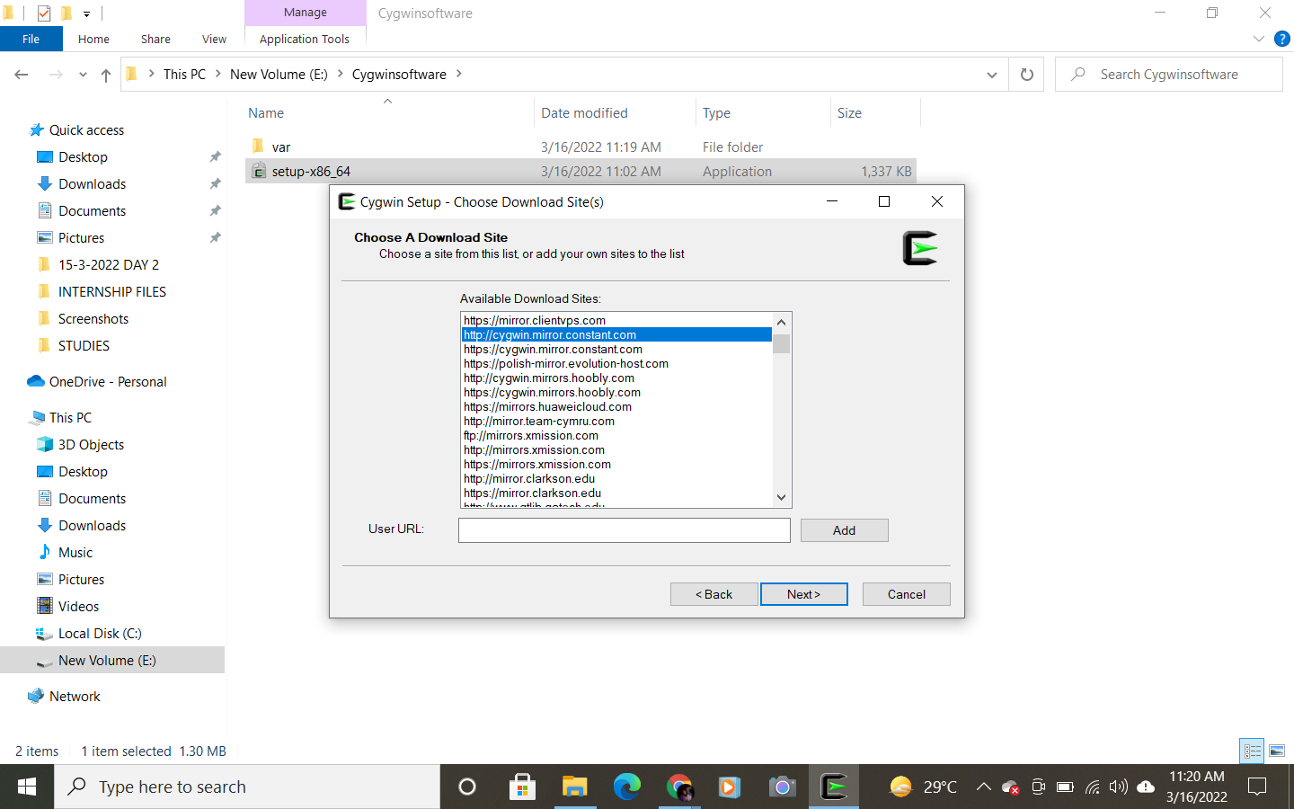

- Go to category and select Full
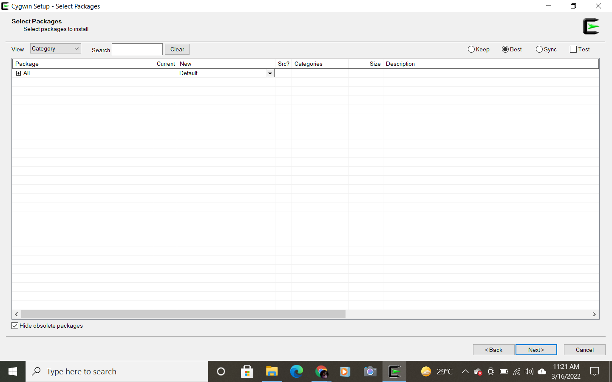

- Now type the required packages in the search bar and double click on skip.
- Required packages are
gcc-core
gdb
make
vim
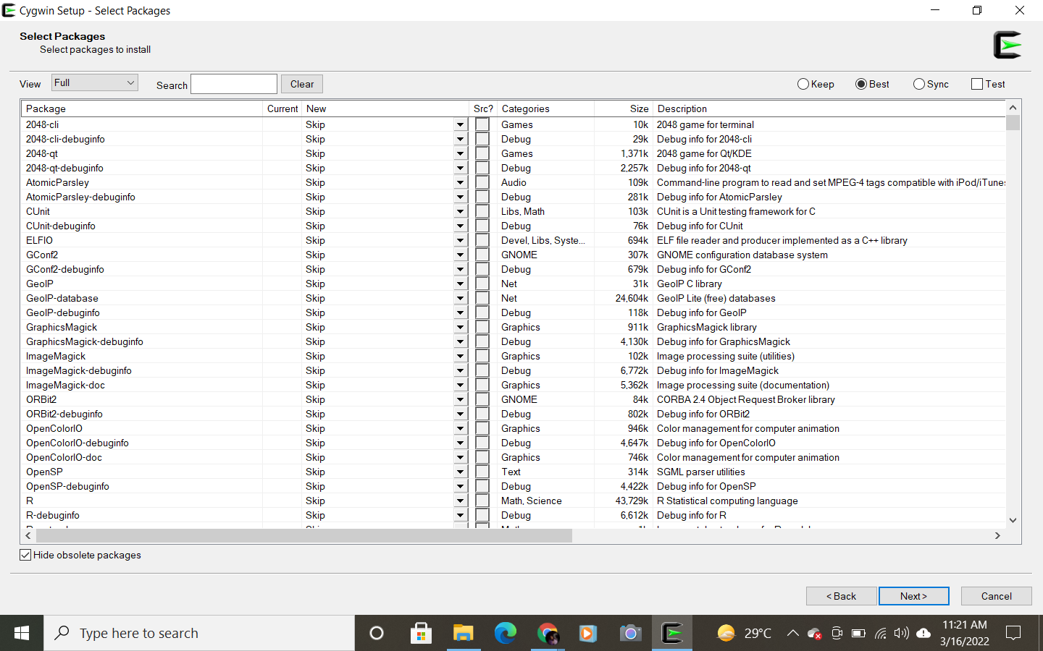

- The packages gets installed, click on next
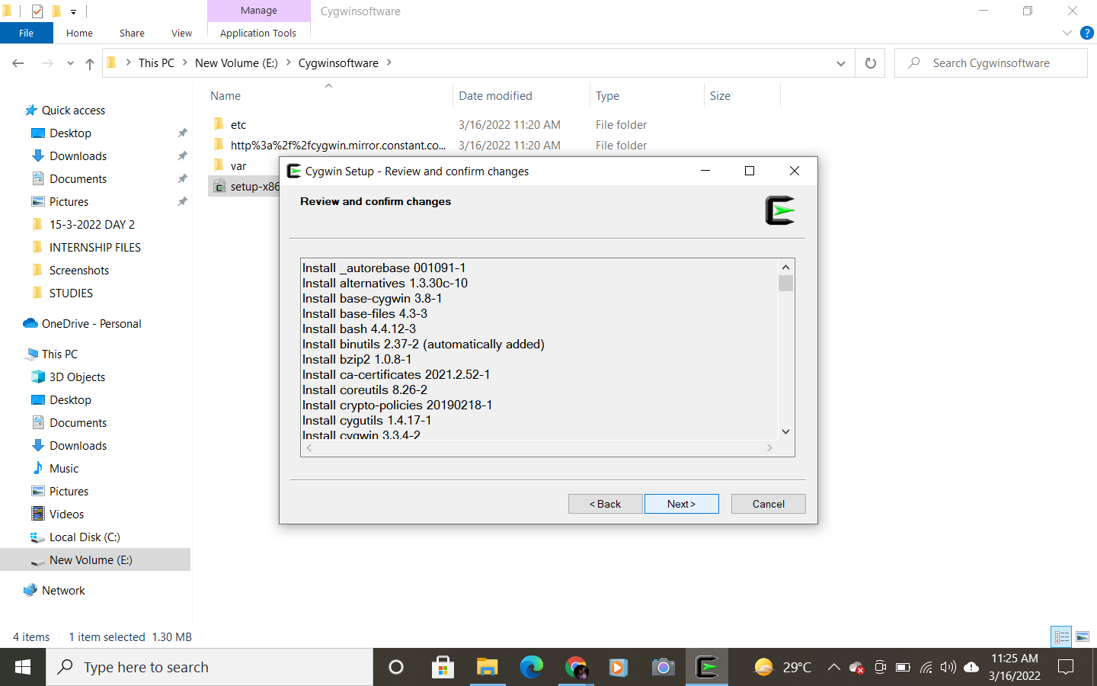

- Wait for it to get installed
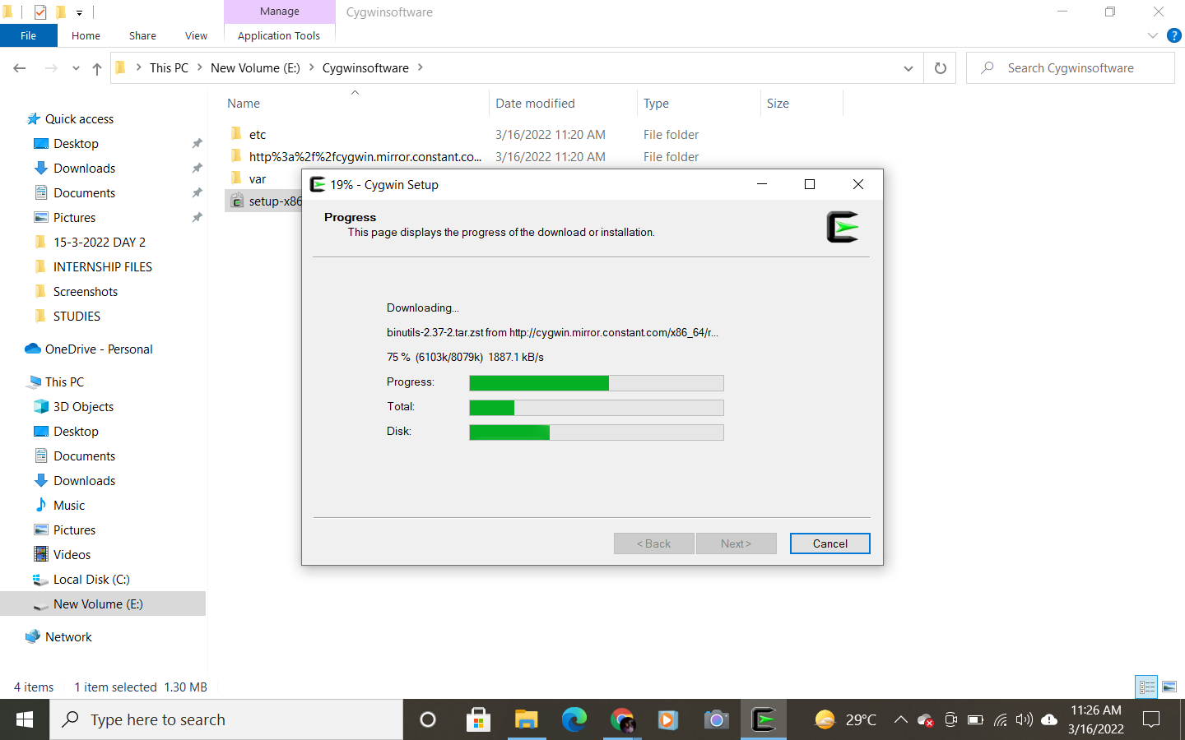

- Finish the setup
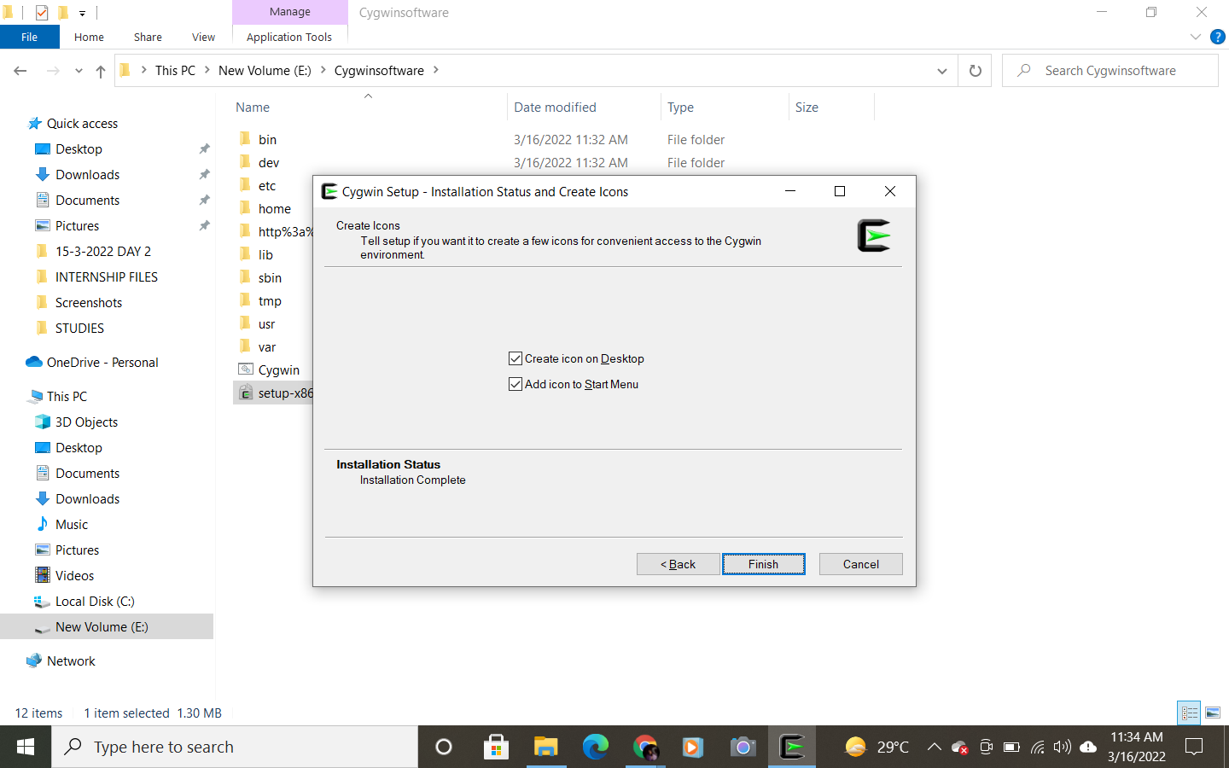

- Copy the bin location
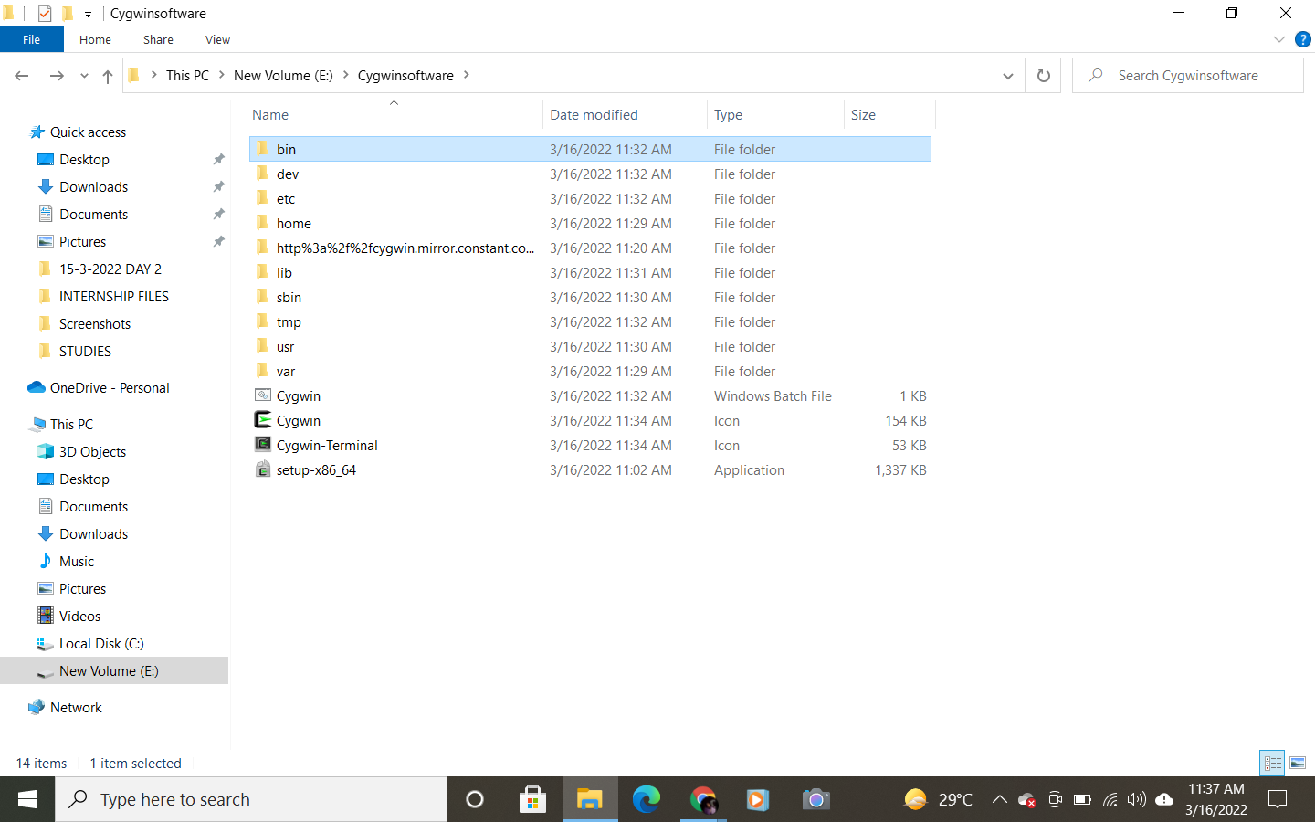
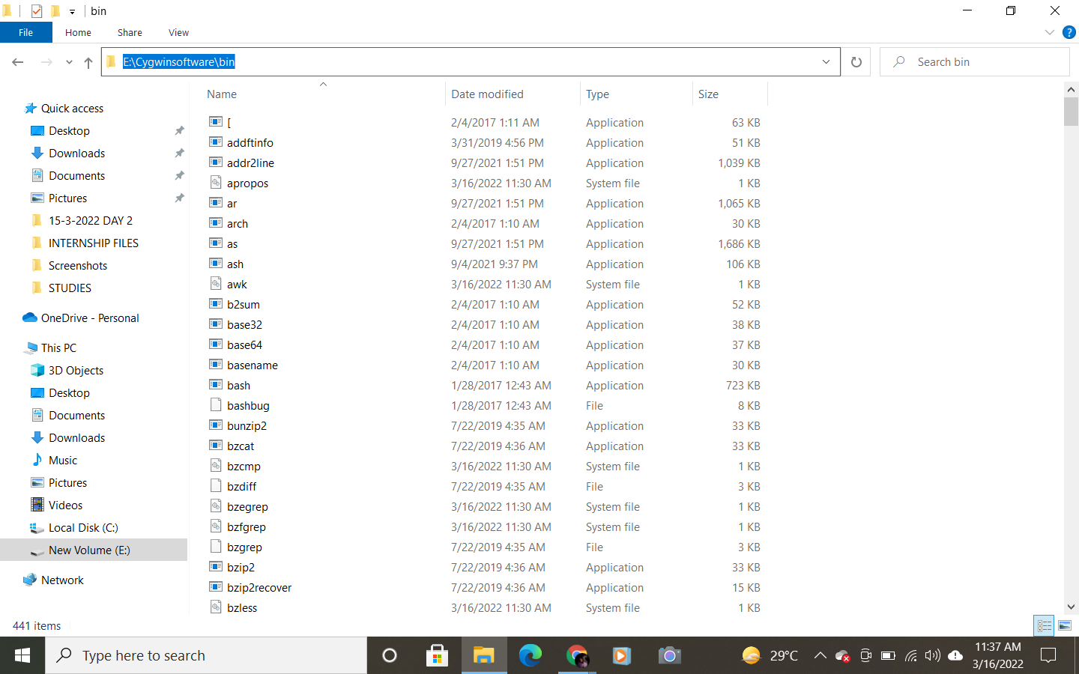

- Go to my pc, right lick properties
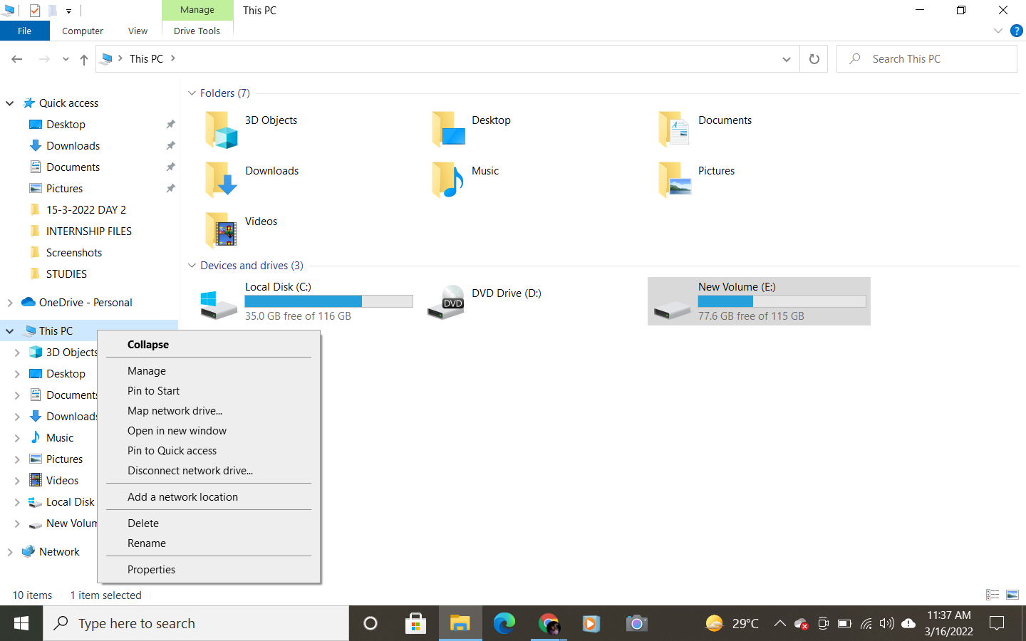
- Click on advanced system settings
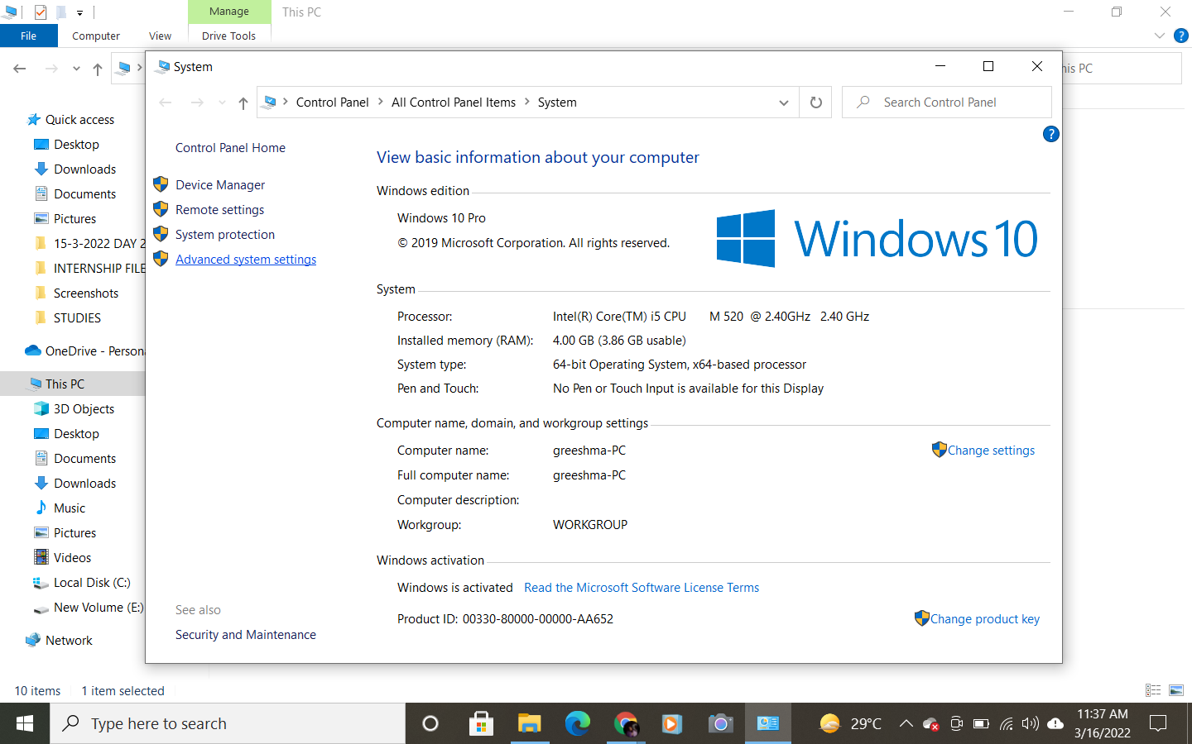

- Click on environmental variables
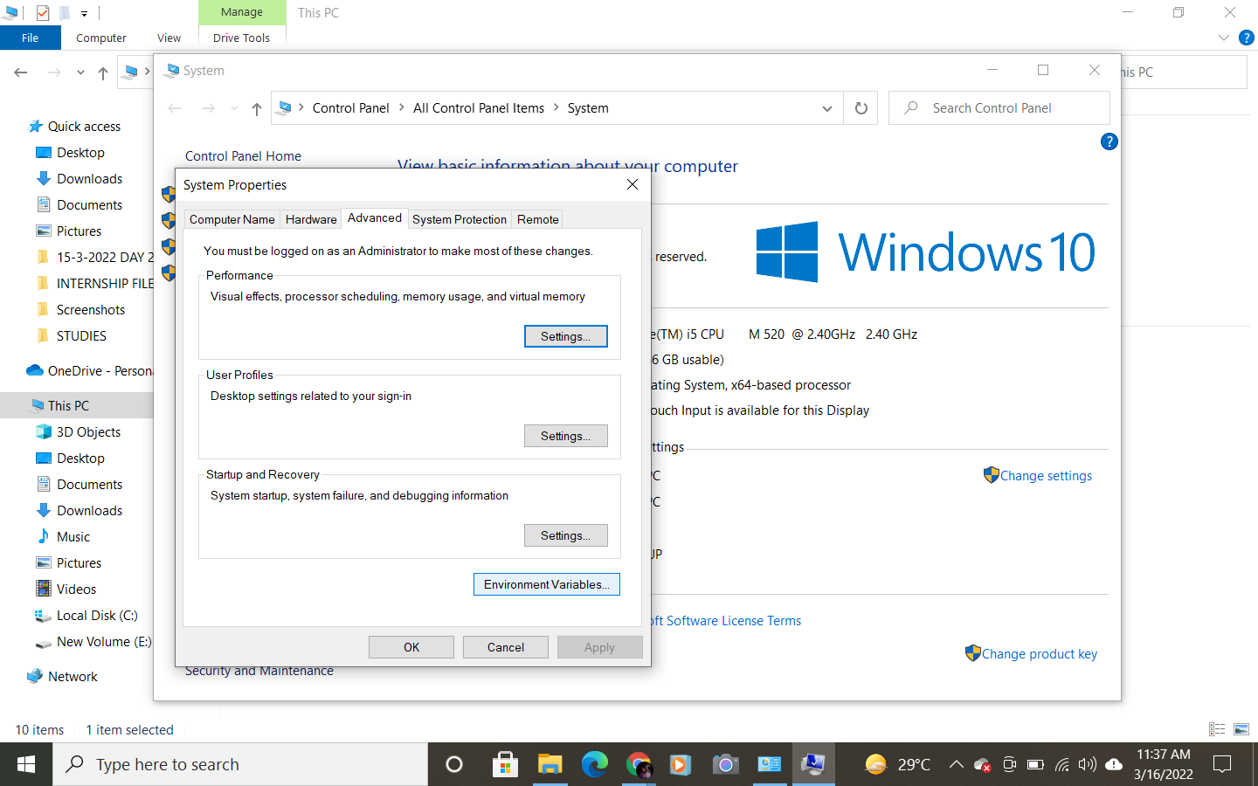

- Select path and click on edit
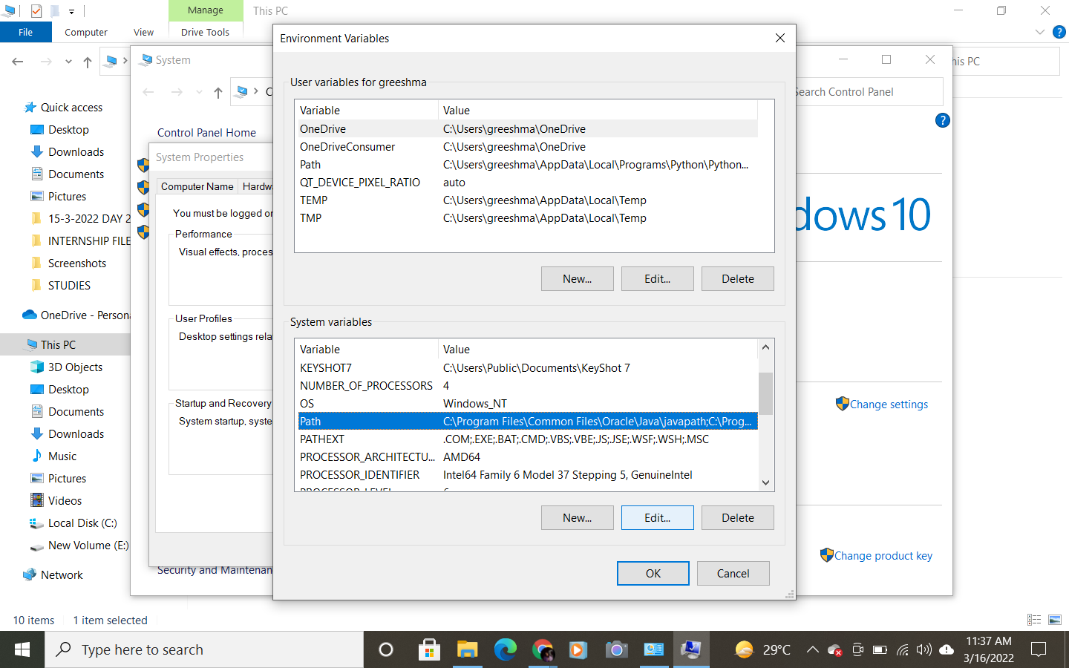

- Click on new and edit text
- Paste the path location here with a semicolon
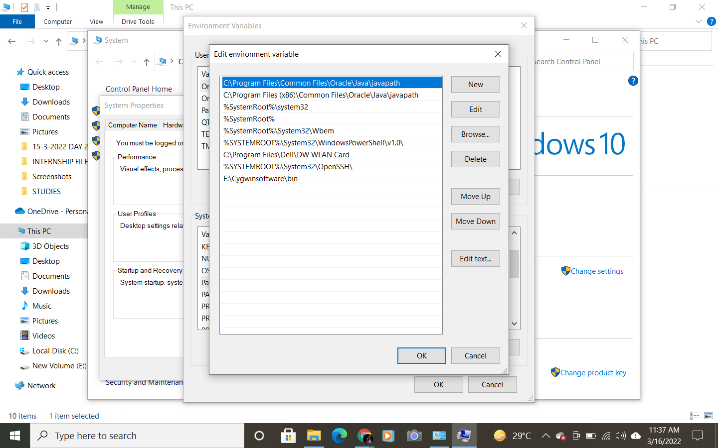

- Go to command prompt and give the below commands to check if the packages are installed.
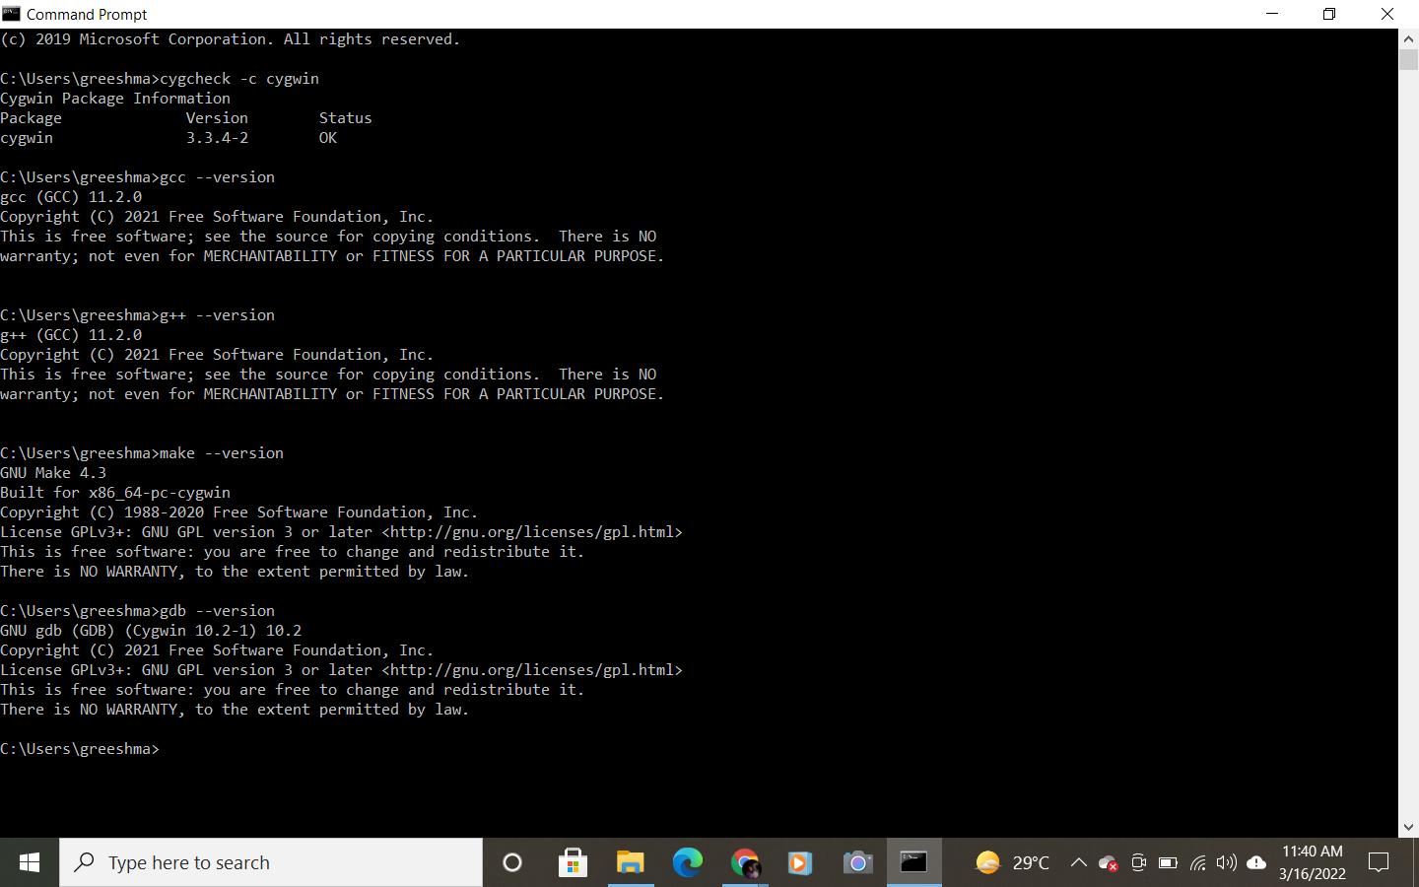

STEP-2 (Install JRE and add path to environmental variables )
- Go to the https://download.eclipse.org/oomph/jre/?vm=1_1_6_0_64_0
- Download the software
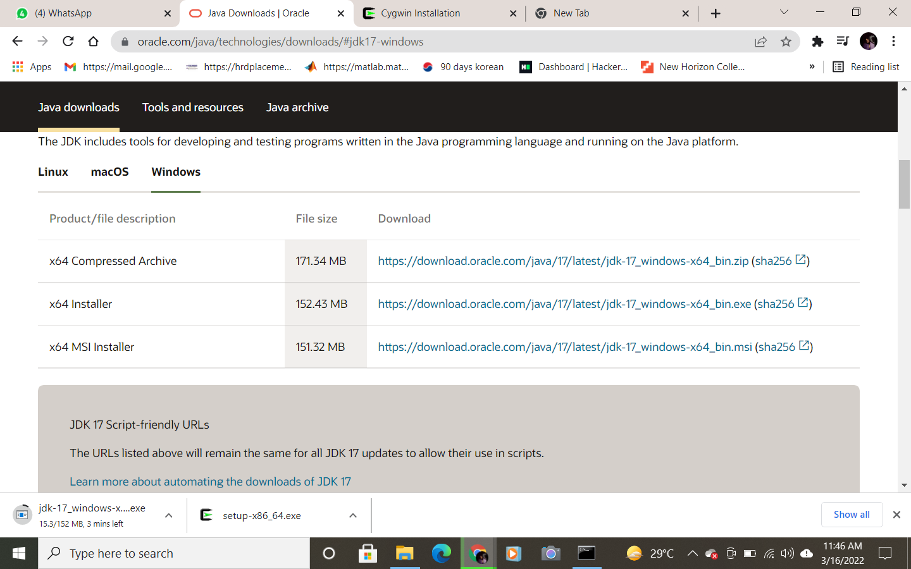
- Install.
Step-3 ( Install Eclipse IDE for C/C++ developer )
- Install Eclipse software
- Select C/C++

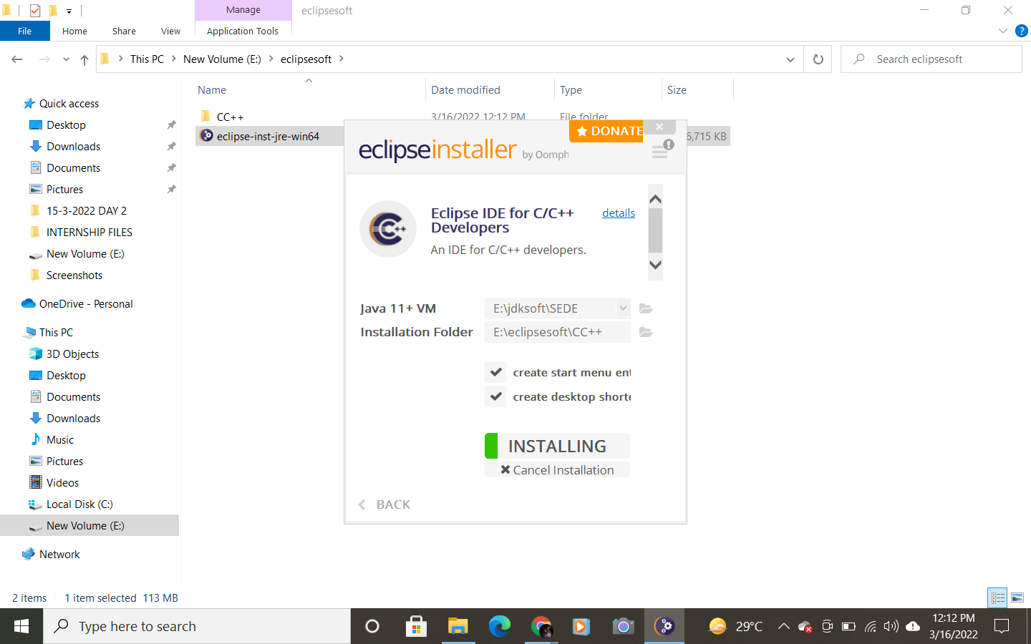

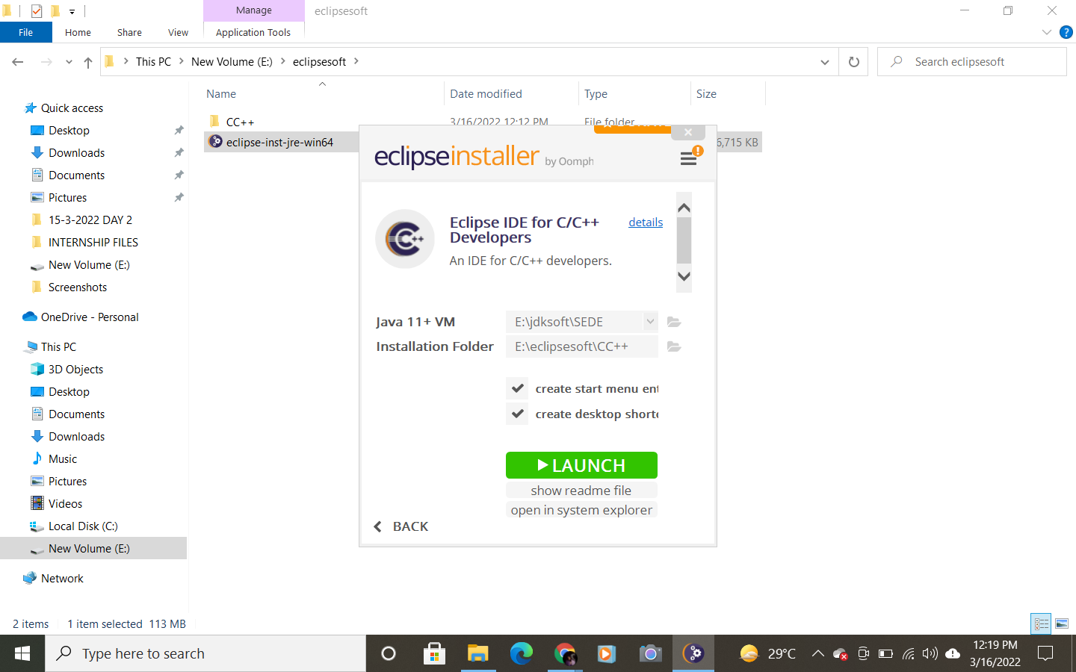
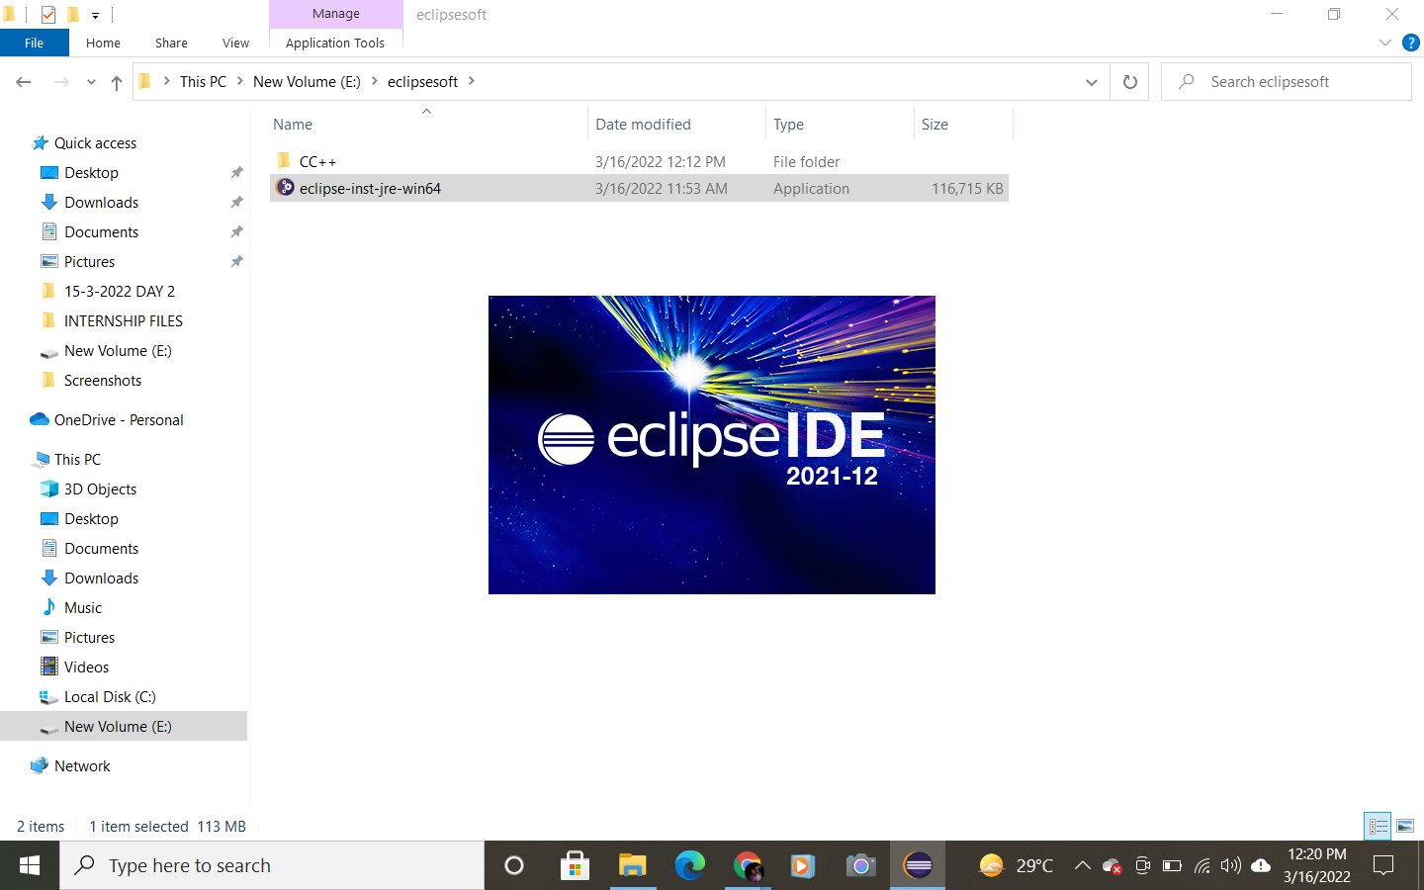

THANK YOU

